**Journey Through The Bible**

**Prodigal Son**

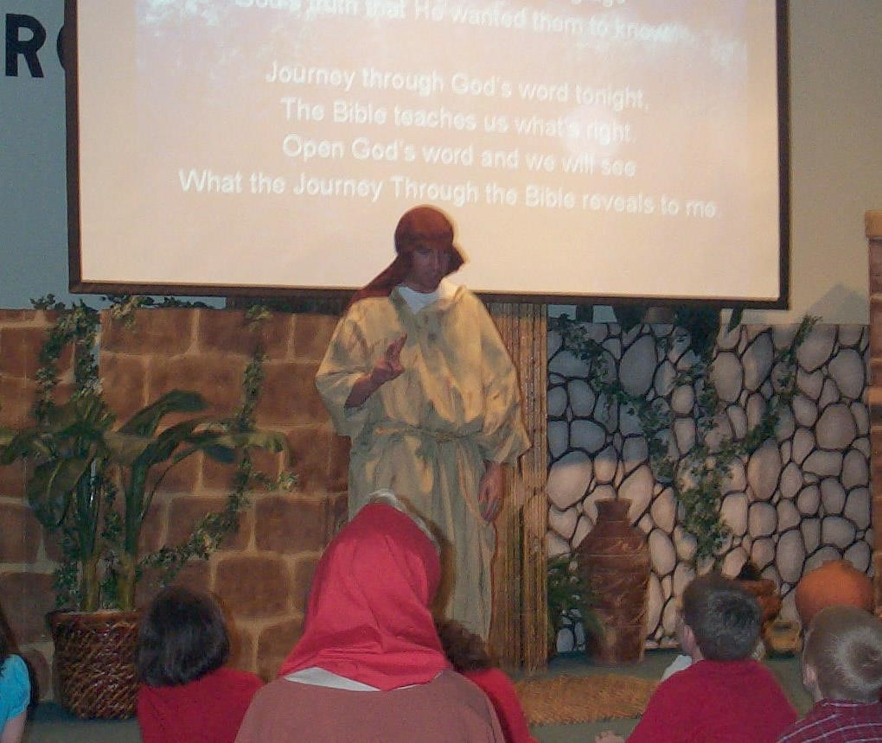

My father has two sons. I am the youngest.

When I became old enough to think that I could make my own decisions I told my father to give me my part of his money. It really wasn’t mine, but being the rebellious son that I was I asked for it anyway. My father did what I asked him to do.

Believing I knew what I was doing I took the money and went away to a far off town. As you might guess, I spent the money my father had given me foolishly on very bad things, which I knew were wrong!

Guess what! When I had wasted all of my money I had no place to stay and nothing to eat. No one would do anything for me.

Finally, a man let me live on his farm if I would fee his pigs! This was the worst thing a young Jewish man like me could even imagine!

I was so hungry that I started to eat the pig’s food. When I came to my senses I began to think that my father’s hired men had plenty to eat! I was so hungry that I decided to go home to my father and tell him that I had sinned against him and God and that I was no longer worthy to be his son. I would just ask him if I could be one of his hired men.

When I came near to my home my father, who had been looking for me to come home, came running to meet me, threw his arms around me and hugged me and kissed me and welcomed me home. I told him that I had sinned against heaven and against him and was no longer worthy to be his son.

But my father said to his servants, “Quick! Bring clothes for him to wear and a ring for his finger and sandals for his feet! Bring food and let’s eat and have a party for my son was lost and now he is found!”

We began to laugh, eat and enjoy talking to each other! You cannot imagine what joy I feel to be home again!

My stomach is full and my heart is so full of joy that my father has forgiven me and my foolish behavior!

God is like my father. When we do bad things and are truly sorry, we need to tell Him so, he will always forgive us.

If you want to ready more about me, open your Bibles to the book of Luke. Now I would like to ask you some questions. (Prepare several questions to ask.)

**Scripture reading**: Luke 15:13-32 **Memory Verse:** John 14:6

"I am the way, the truth, and the life. No one comes to the Father except through Me.